Kubernetes Task -01

Task Title
Kubernetes Environment Setup and NGINX Deployment
Objective
The objective of this task was to establish a functional Kubernetes environment across both local and cloud-based infrastructure. This involved:
• Setting up a local Kubernetes cluster using Minikube
• Configuring a multi-node Kubernetes cluster using kubeadm on Ubuntu
• Deploying and validating a containerized application (NGINX pod)
The goal was to gain hands-on experience with Kubernetes installation, cluster configuration, node management, and workload deployment.
Prerequisites
The following prerequisites were required before performing the setup:
Local Environment Requirements (Minikube)
• System with virtualization enabled
• Docker installed and running
• kubectl installed
• Minikube binary installed
• Minimum hardware recommendation:
• 2 CPU cores
• 4 GB RAM
Cloud / Ubuntu Cluster Requirements
• Ubuntu-based EC2 instances (or VMs)
• Minimum nodes:
• 1 Master Node
• 2 Worker Nodes
• Required configurations:
• Swap disabled on all nodes
• Hostname configuration
• Network connectivity between nodes
• Required ports opened (security groups / firewall)
Software Dependencies
Installed on all nodes:
• kubeadm
• kubelet
• kubectl
• containerd (container runtime)
Networking Requirements
• Pod network CIDR planning
• CNI plugin (Calico) installation

Conclusion
The task was completed successfully by achieving the following outcomes:
• Minikube cluster was installed and initialized in the local environment
• Kubernetes master node and two worker nodes were configured on Ubuntu
• Node communication and networking were validated
• Container runtime and Kubernetes components were properly installed
• Cluster networking was established using Calico
• Worker nodes were successfully joined to the cluster
• NGINX pod was deployed and verified in a Running state
This exercise demonstrated:
• Understanding of Kubernetes architecture
• Practical experience with kubeadm-based cluster setup
• Node management and troubleshooting skills
• Workload deployment and validation
The Kubernetes environment is now fully operational and ready for further application deployments, scaling exercises, and service exposure configurations.
- Setup Minikube in your local machine.
Steps Performed – Minikube Setup on Windows
Step 1: Verified Docker Installation
Checked whether Docker was installed and running.
docker --version
Confirmed Docker version was available.

Step 2: Opened Minikube Official Documentation
Accessed Minikube installation guide via browser.
start https://minikube.sigs.k8s.io/docs/start/

Step 3: Created Directory for Minikube Binary
Created a dedicated folder inside the C drive.
New-Item -Path 'c:\' -Name 'minikube' -ItemType Directory -Force
Successfully created:
C:\minikube

Step 4: Downloaded Minikube Executable
Downloaded Minikube binary from GitHub releases.
Invoke-WebRequest -OutFile 'c:\minikube\minikube.exe' -Uri 'https://github.com/kubernetes/minikube/releases/latest/download/minikube-windows-amd64.exe'
Minikube executable downloaded successfully.

Step 5: Configured Environment Variables (PATH)
Added Minikube directory to system PATH.
Steps:
• Opened System Properties
• Navigated to Environment Variables
• Edited PATH variable
• Added:
C:\minikube
Step 6: Verified Minikube Installation
Validated Minikube binary.
minikube version
Confirmed installed version:
minikube version: v1.38.0
Step 7: Started Minikube Cluster
Initialized local Kubernetes cluster using Docker driver.
minikube start --driver=docker
Observed:
• Container runtime detection
• Image downloads
• Kubernetes components initialization
• CNI configuration
Cluster started successfully.
Step 8: Verified Cluster IP
Retrieved Minikube IP address.
minikube ip
Output:
192.168.49.2

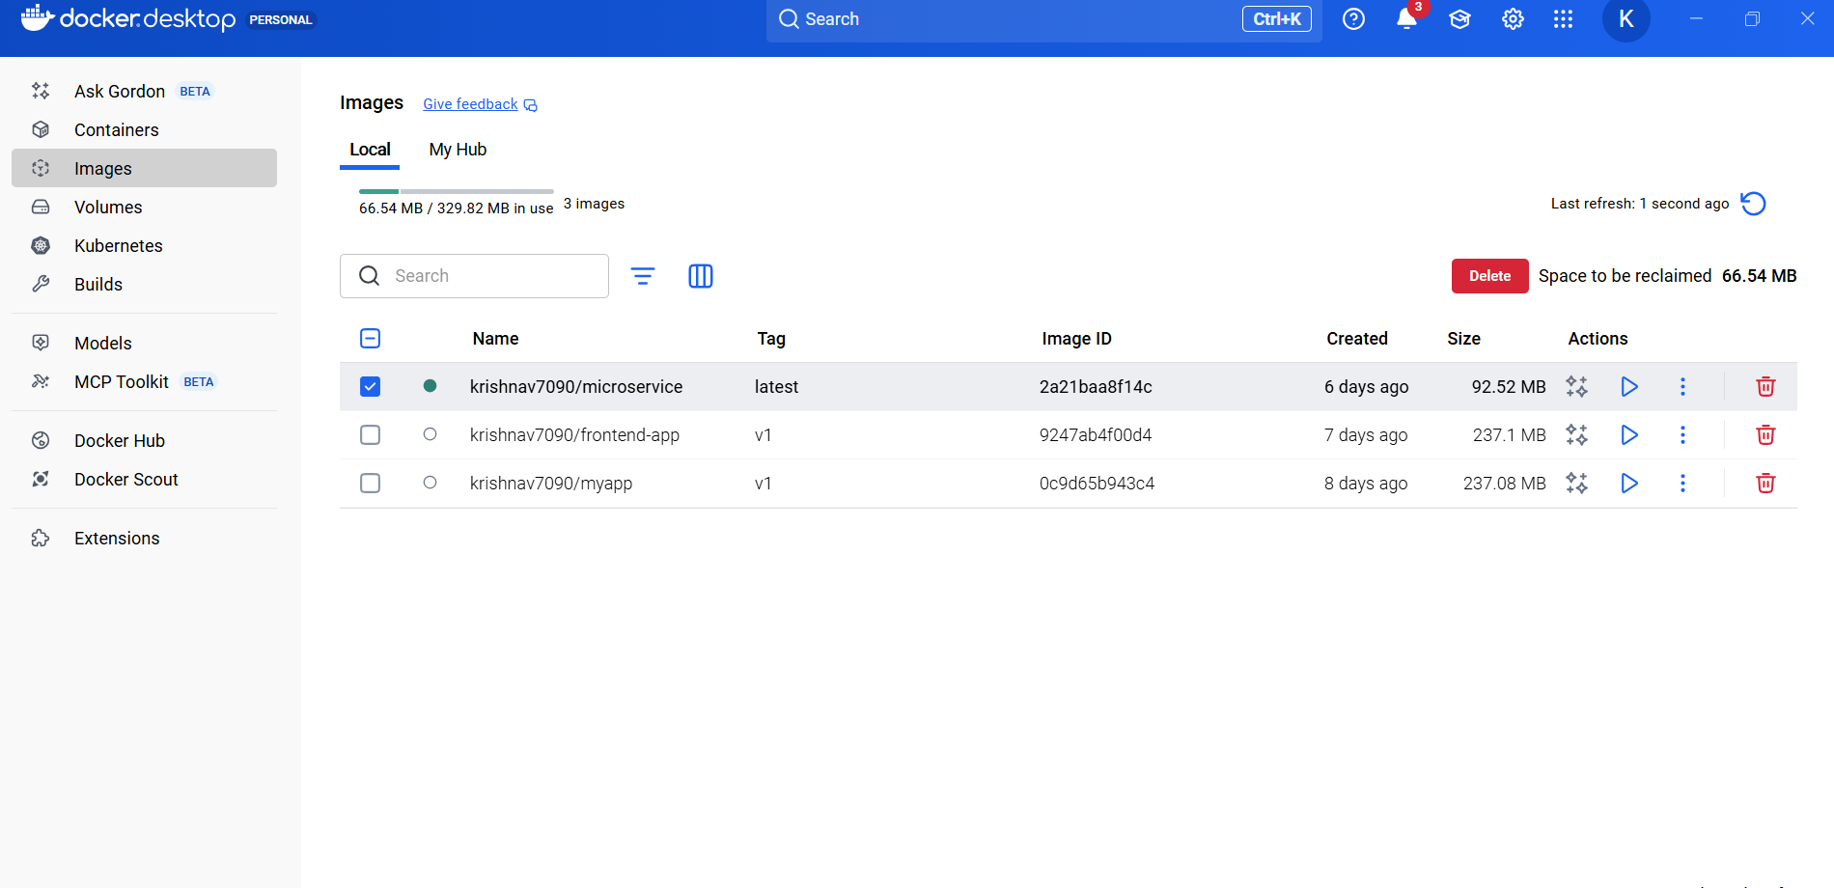
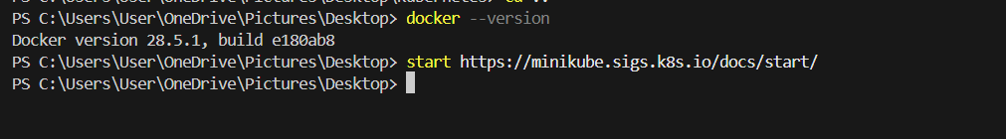
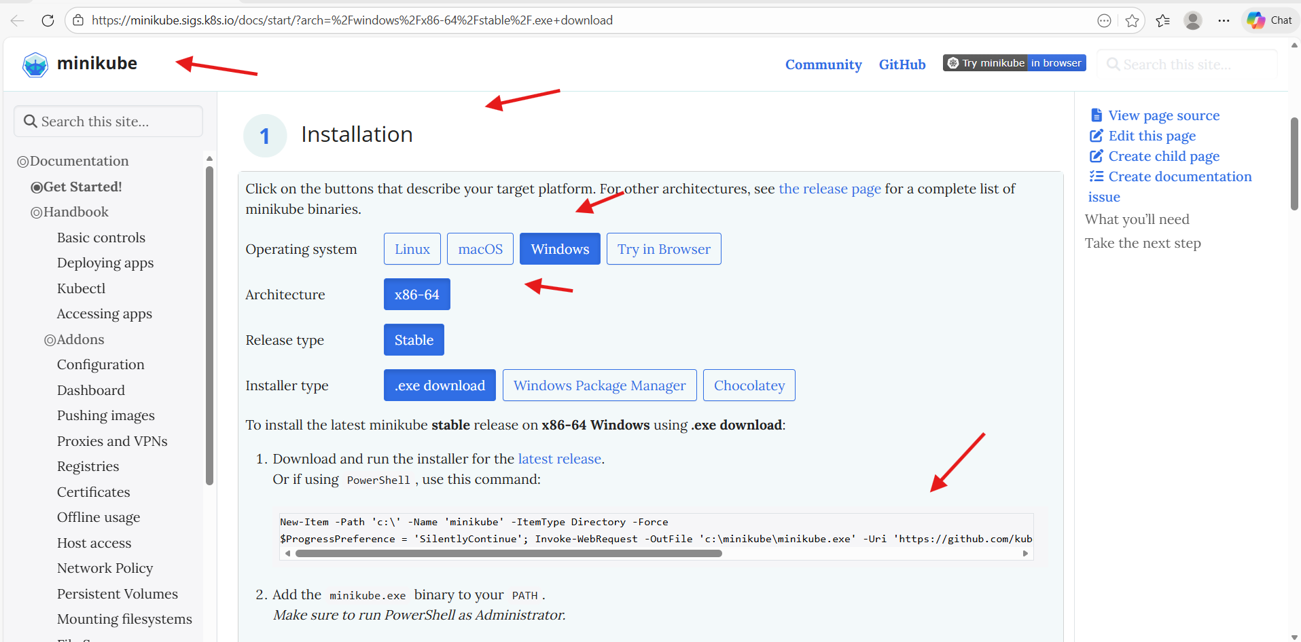
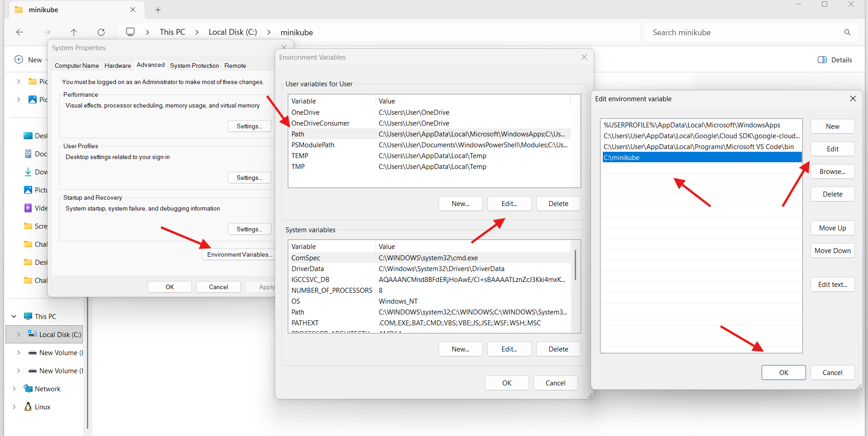
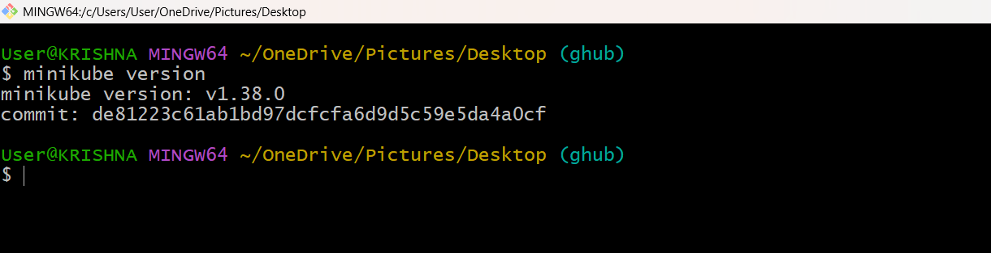
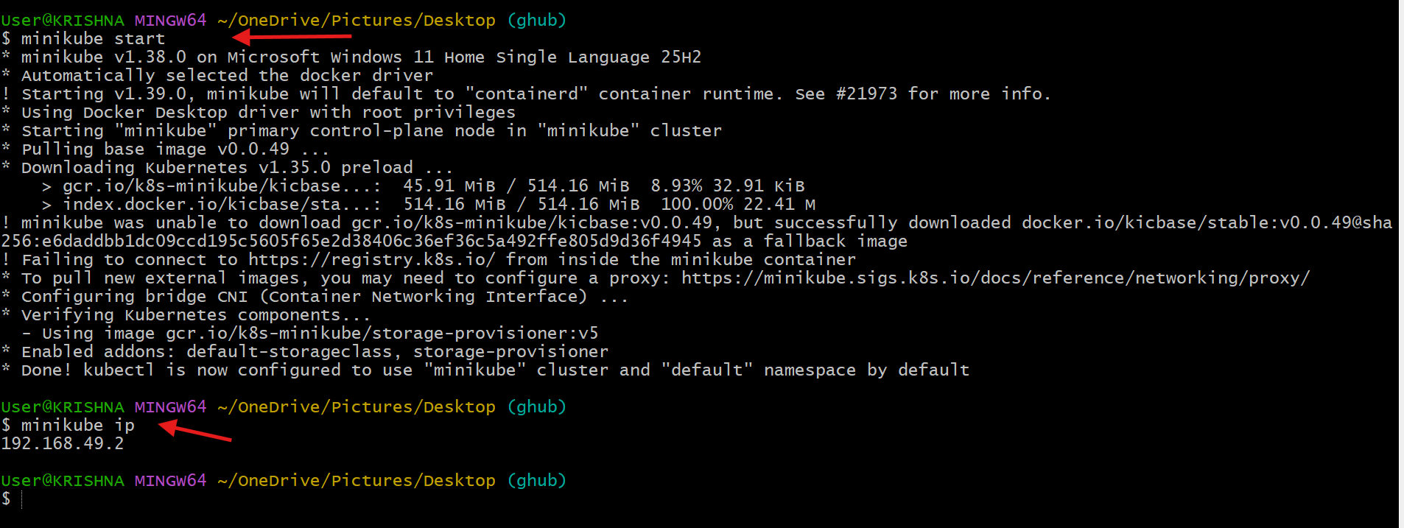

- Setup k8s master and two worker nodes on ubuntu.
Steps Performed – Kubernetes Cluster Setup
Step 1: Launched EC2 Instances
Created EC2 instances via AWS Console.
Configuration:
• Selected Ubuntu AMI
• Configured instance type
• Added Name tags
Instances created:
• Kubernetes-Master
• Kubernetes-Worker-01
• Kubernetes-Worker-02
Verified instance state → Running
Step 2: Connected to Instances via SSH
Established SSH connection to:
• Master Node
• Worker Nodes
Validated terminal access.
Step 3: Disabled Swap (Required for Kubernetes)
Executed on ALL nodes:
sudo swapoff -a
free -h
Confirmed swap memory → 0B
Made swap persistent:
sudo sed -i '/ swap / s/^/#/' /etc/fstab

Step 4: Configured Hostnames
Assigned hostnames for identification.
Master Node:
sudo hostnamectl set-hostname k8s-master
Worker Nodes:
sudo hostnamectl set-hostname worker01
sudo hostnamectl set-hostname worker02

Step 5: Updated Hosts File
Configured internal DNS resolution.
Executed on ALL nodes:
sudo vi /etc/hosts
Added:
<Master-PrivateIP> master
<Worker1-PrivateIP> worker-01
<Worker2-PrivateIP> worker-02

Step 6: Verified Node Connectivity
Validated inter-node communication:
ping master
ping worker-01
ping worker-02
Confirmed network connectivity between nodes.

Step 7: Loaded Required Kernel Modules
Executed on ALL nodes:
cat <<EOF | sudo tee /etc/modules-load.d/k8s.conf
overlay
br_netfilter
EOF
Activated modules:
sudo modprobe overlay
sudo modprobe br_netfilter

Step 8: Configured Sysctl Parameters
Executed on ALL nodes:
cat <<EOF | sudo tee /etc/sysctl.d/k8s.conf
net.bridge.bridge-nf-call-iptables = 1
net.bridge.bridge-nf-call-ip6tables = 1
net.ipv4.ip_forward = 1
EOF
Applied configuration:
sudo sysctl --system

Step 9: Installed Kubernetes Components
Executed on ALL nodes:
sudo apt update
sudo apt install -y kubelet kubeadm kubectl
sudo apt-mark hold kubelet kubeadm kubectl
Installed:
• kubelet
• kubeadm
• kubectl
Step 10: Installed Container Runtime (containerd)
Executed on ALL nodes:
sudo apt install -y containerd
sudo mkdir -p /etc/containerd
containerd config default | sudo tee /etc/containerd/config.toml
Enabled Systemd cgroup:
sudo sed -i 's/SystemdCgroup = false/SystemdCgroup = true/' /etc/containerd/config.toml
Restarted container runtime:
sudo systemctl restart containerd
sudo systemctl enable containerd

Master Node Configuration
Step 11: Pulled Kubernetes Images
Executed on MASTER node:
sudo kubeadm config images pull
Pulled required Kubernetes control plane images.
Step 12: Initialized Kubernetes Master
Executed on MASTER node:
sudo kubeadm init --pod-network-cidr=10.10.0.0/16
Cluster initialized successfully.
Step 13: Configured kubectl Access
Executed on MASTER node:
mkdir -p $HOME/.kube
sudo cp -i /etc/kubernetes/admin.conf $HOME/.kube/config
sudo chown $(id -u):$(id -g) $HOME/.kube/config
Configured kubectl authentication.
Step 14: Verified Master Node
kubectl get nodes
Observed master node registration.

Networking Configuration (Calico)
Step 15: Installed Calico Operator
Executed on MASTER node:
kubectl create -f https://raw.githubusercontent.com/projectcalico/calico/v3.26.1/manifests/tigera-operator.yaml

Step 16: Downloaded Calico Custom Resources
curl https://raw.githubusercontent.com/projectcalico/calico/v3.26.1/manifests/custom-resources.yaml -O

Step 17: Modified Pod Network CIDR
Updated CIDR configuration:
sed -i 's/192.168.0.0\/16/10.10.0.0\/16/g' custom-resources.yaml

Step 18: Applied Calico Configuration
kubectl create -f custom-resources.yaml
Installed cluster networking.
Step 19: Verified Node Status
kubectl get nodes
Nodes progressing toward Ready state.

Worker Node Configuration
Step 20: Generated Worker Join Command
Executed on MASTER node:
kubeadm token create --print-join-command
Generated secure join command.
Step 21: Joined Worker-01 to Cluster
Executed on Worker-01:
sudo kubeadm join <MasterIP>:6443 --token <token> --discovery-token-ca-cert-hash <hash>
Worker-01 joined cluster successfully.
Step 22: Joined Worker-02 to Cluster
Executed on Worker-02:
sudo kubeadm join <MasterIP>:6443 --token <token> --discovery-token-ca-cert-hash <hash>
Worker-02 joined cluster successfully.

Step 23: Verified Cluster Nodes
Executed on MASTER node:
kubectl get nodes
Observed:
• Master Node
• Worker-01
• Worker-02
All nodes in Ready state.
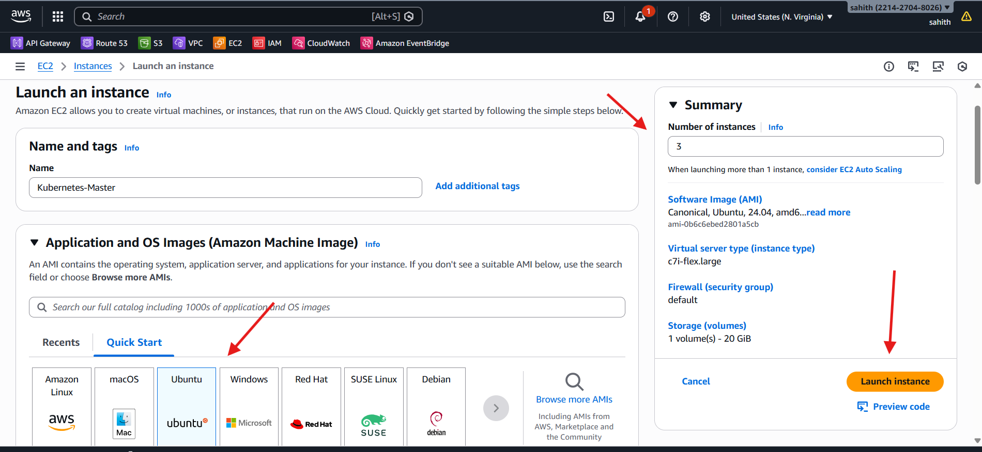
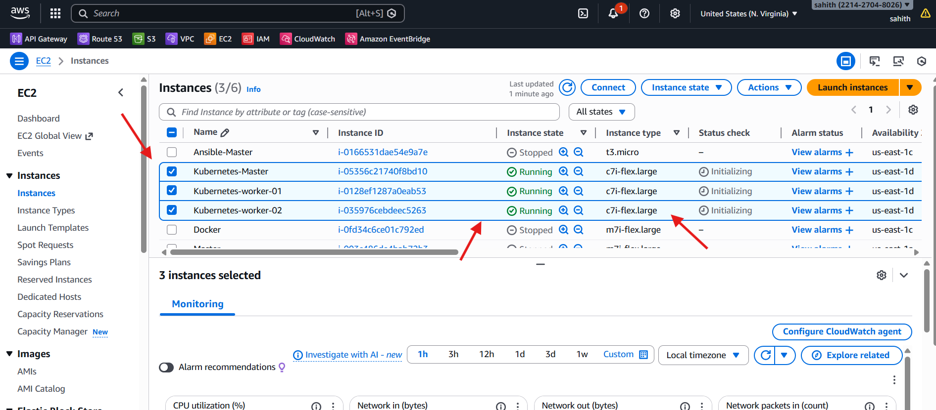
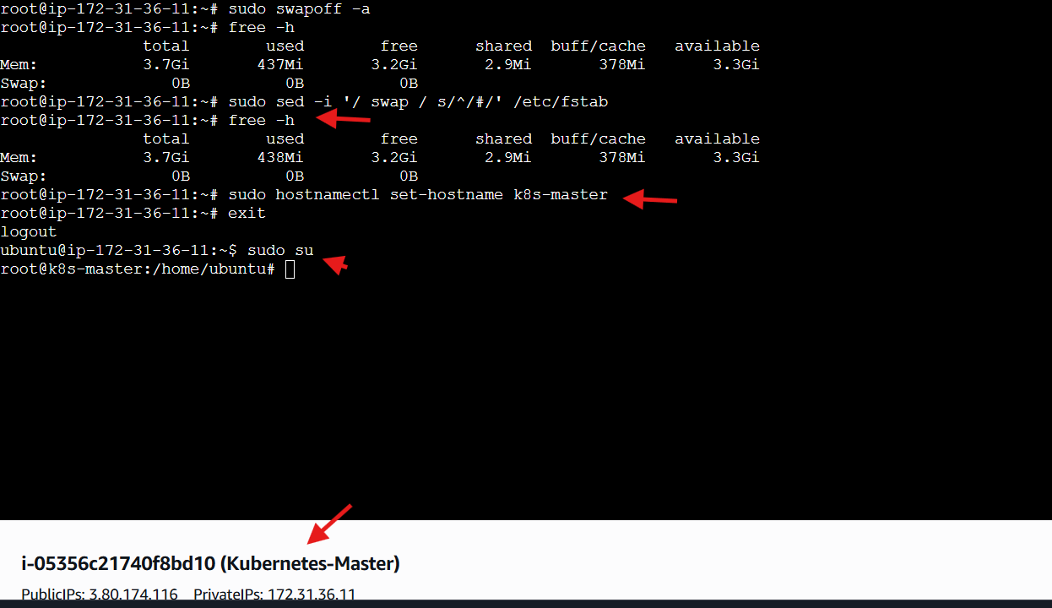
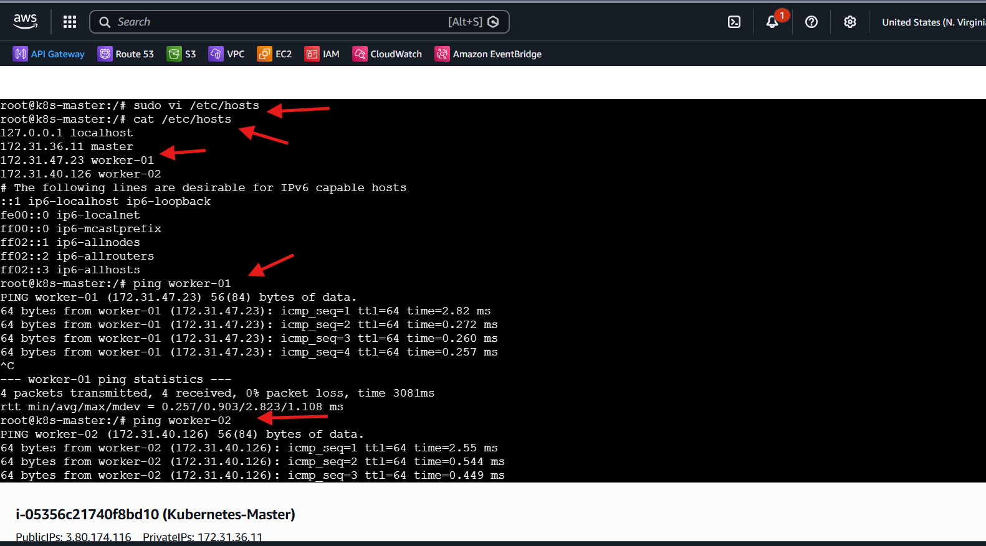
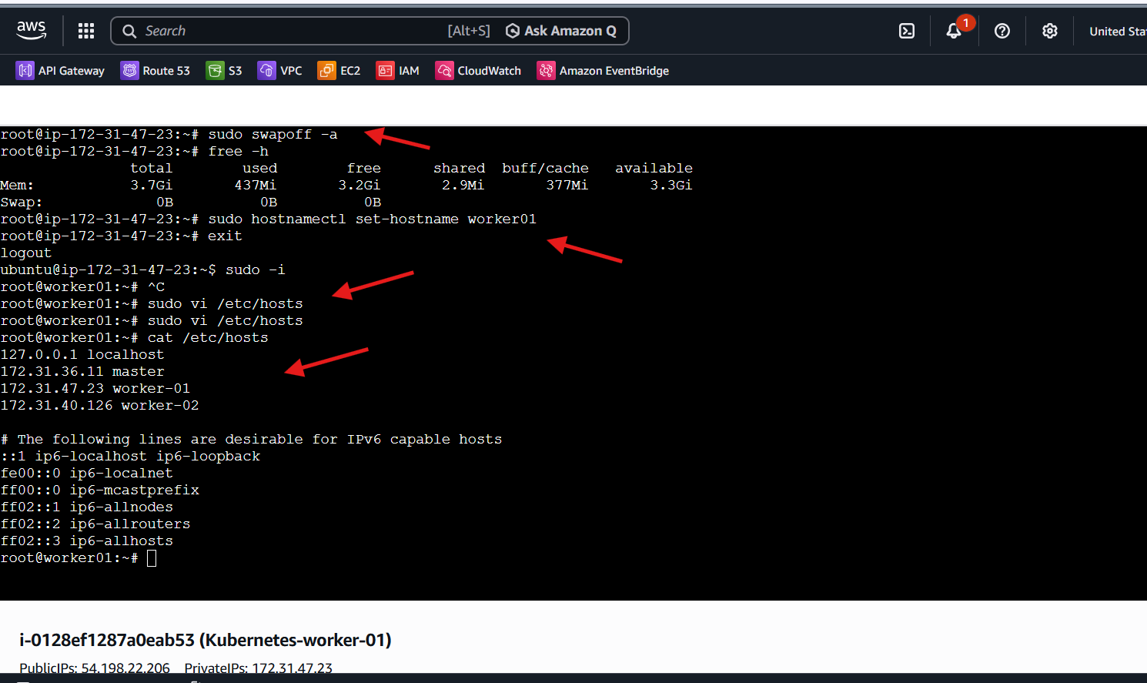
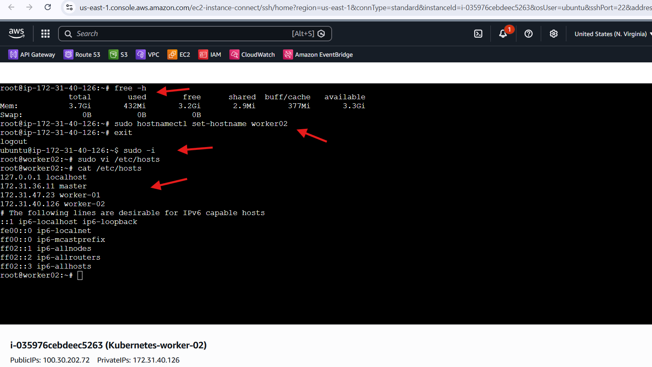
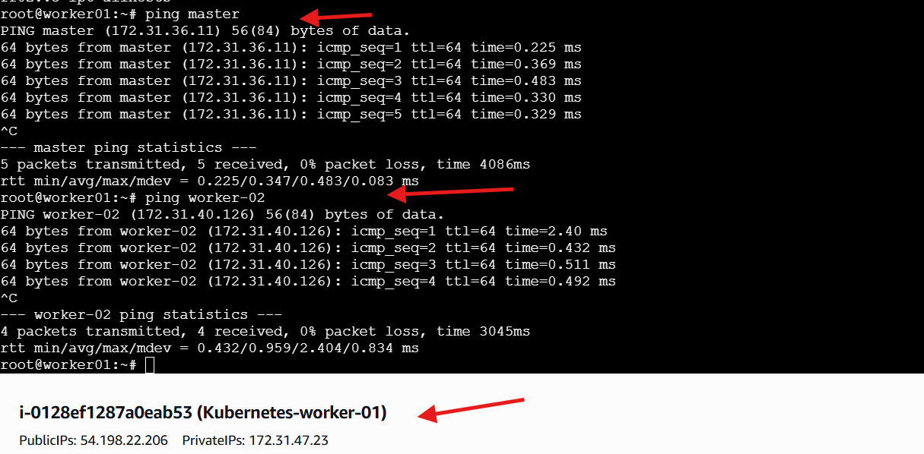
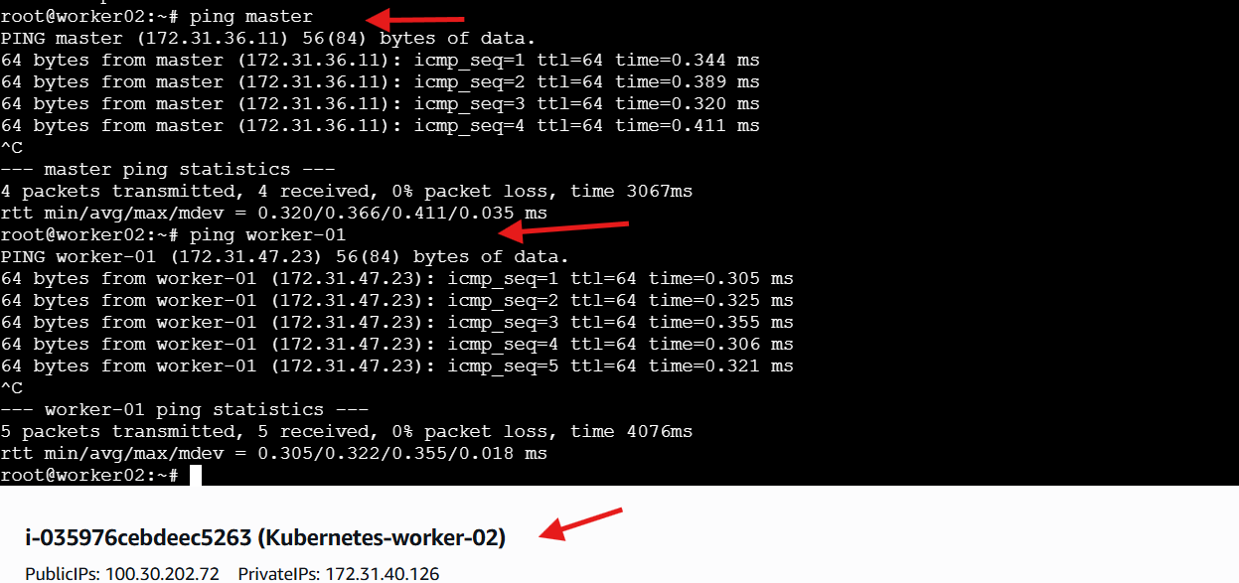
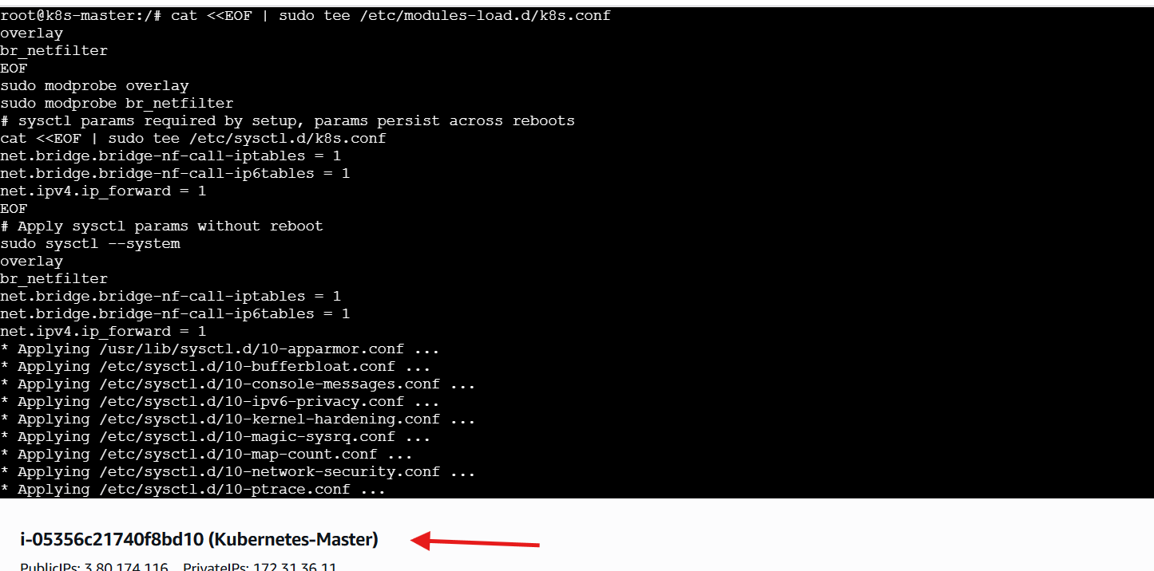
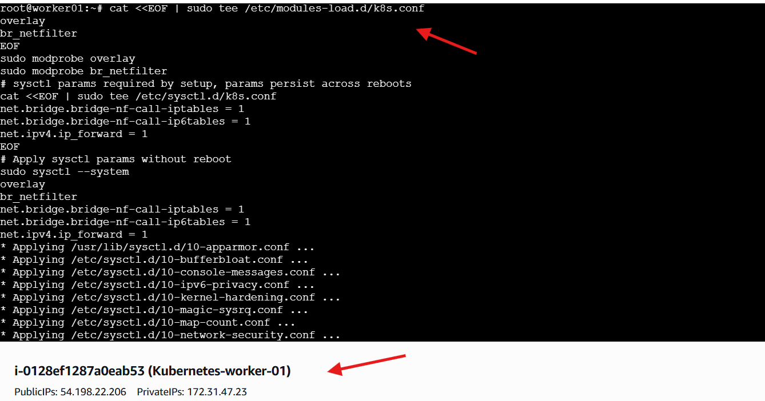
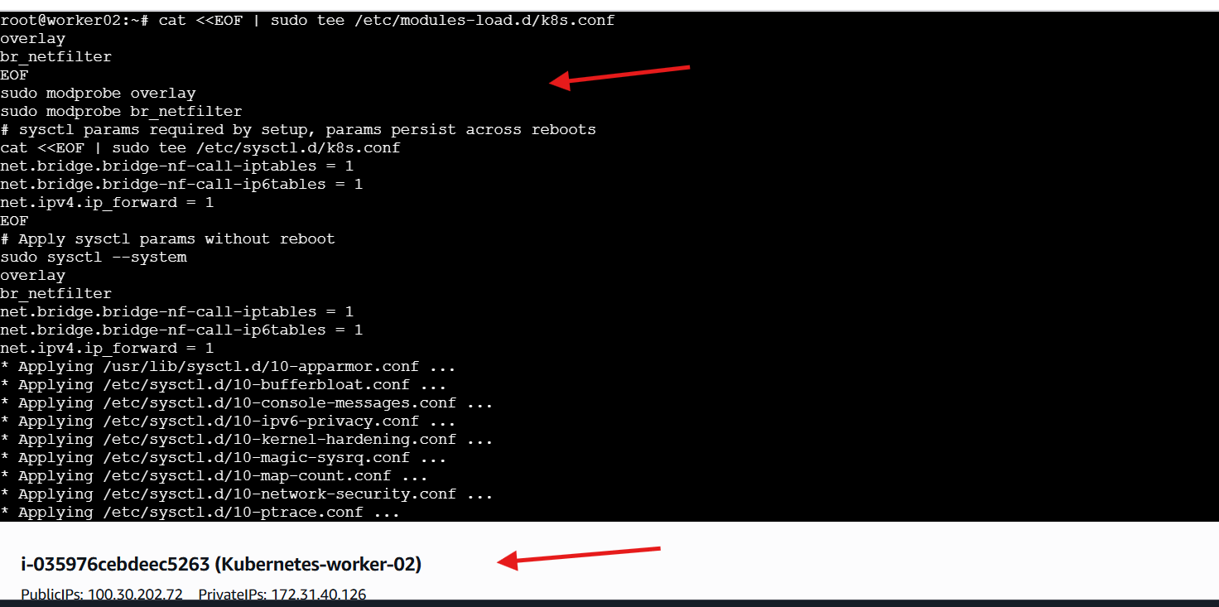
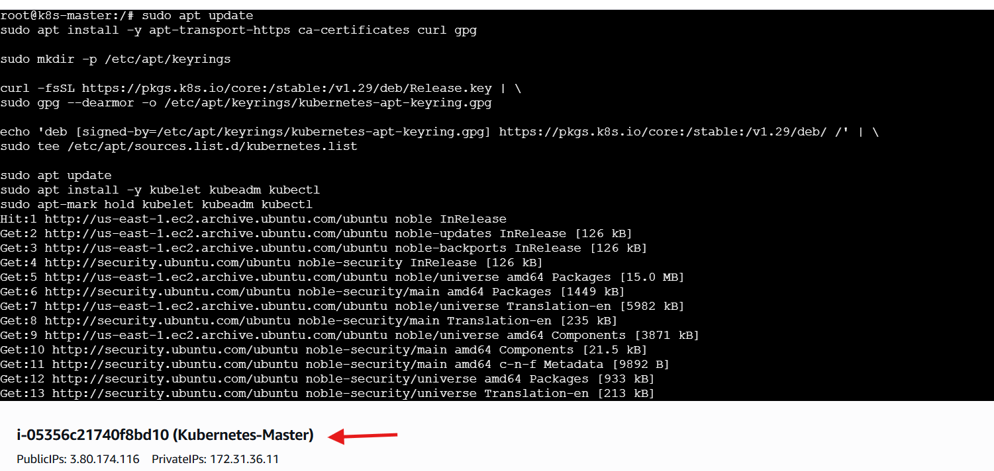
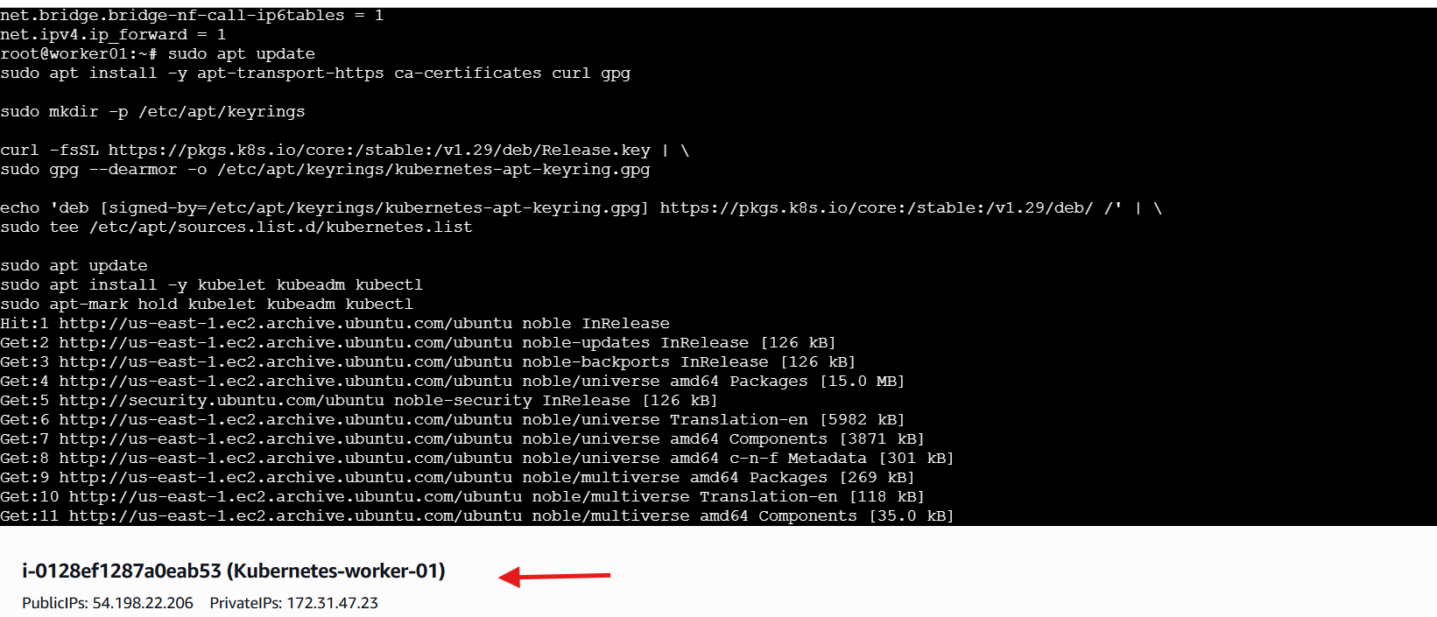
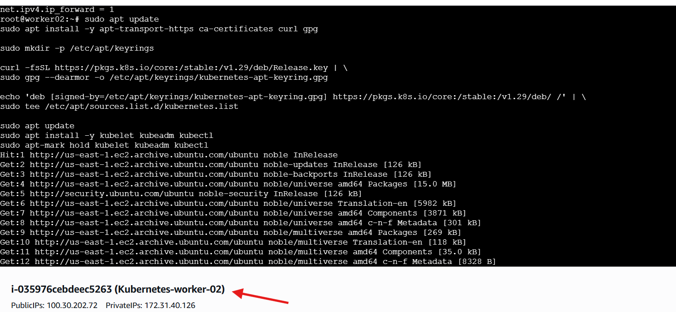
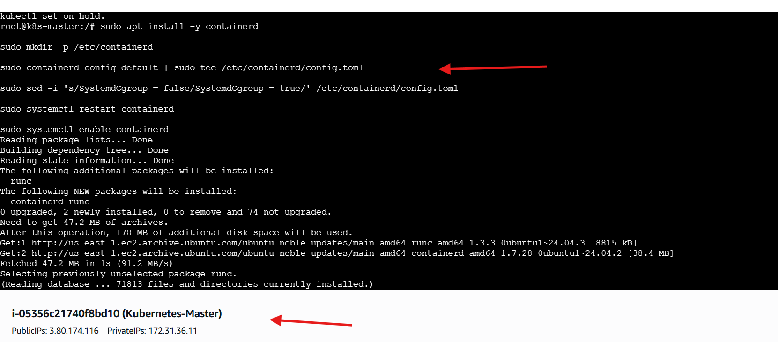
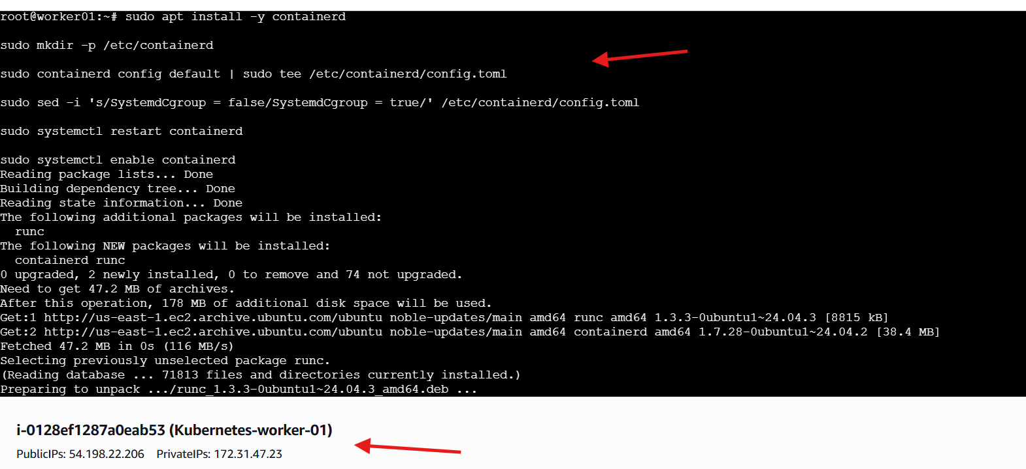
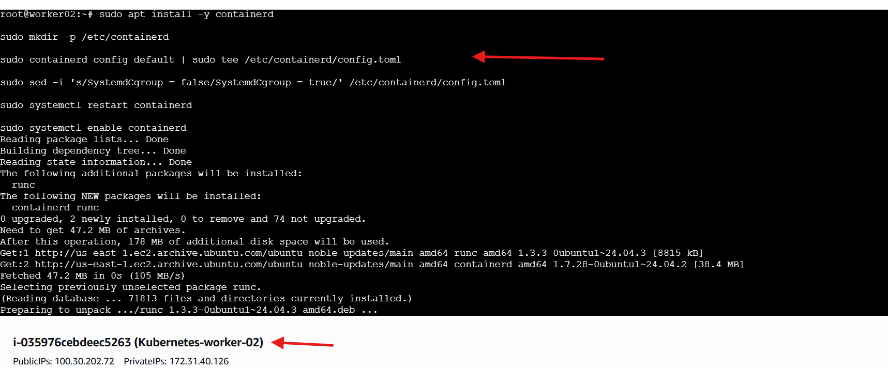
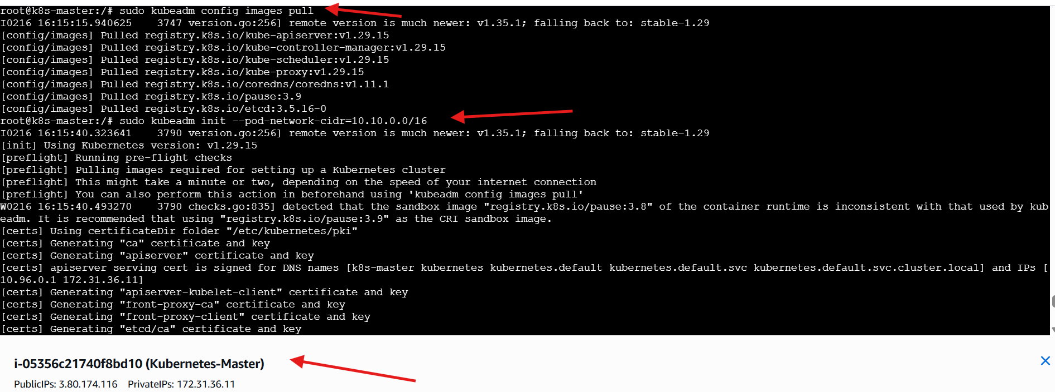
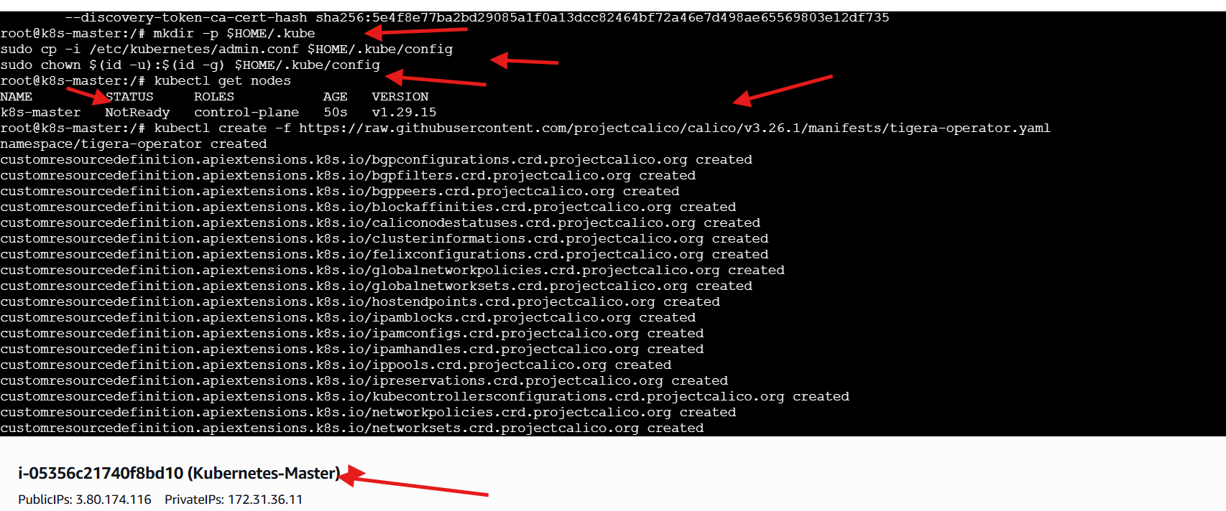
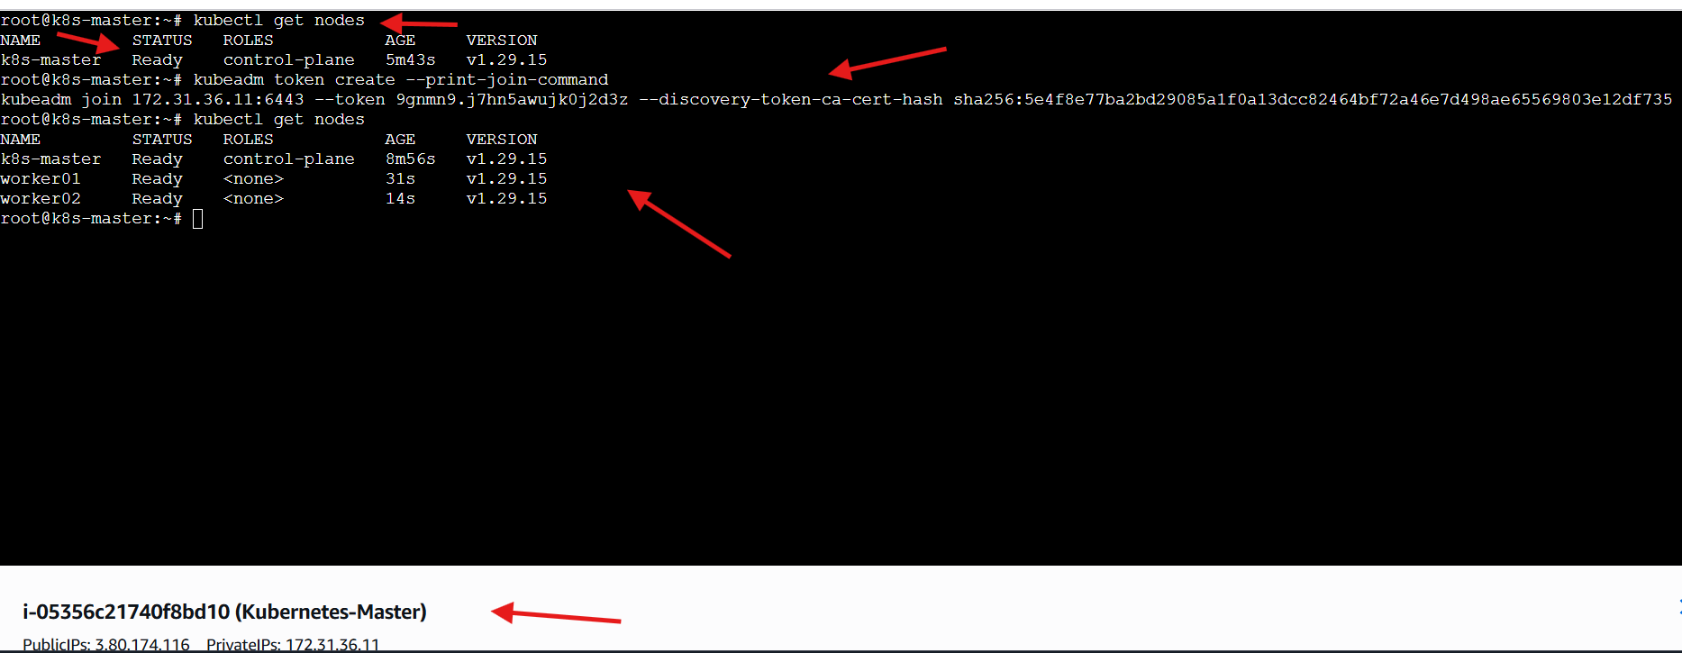
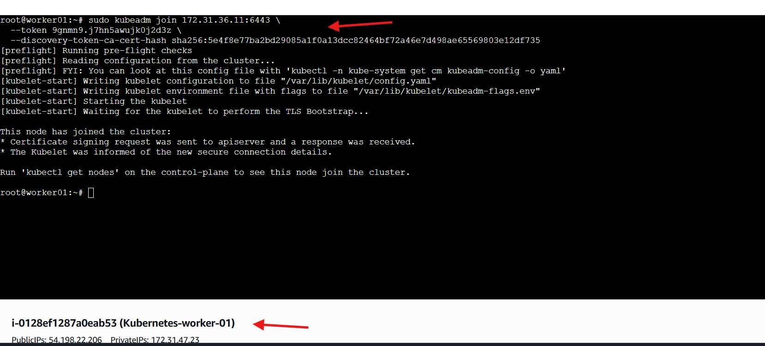
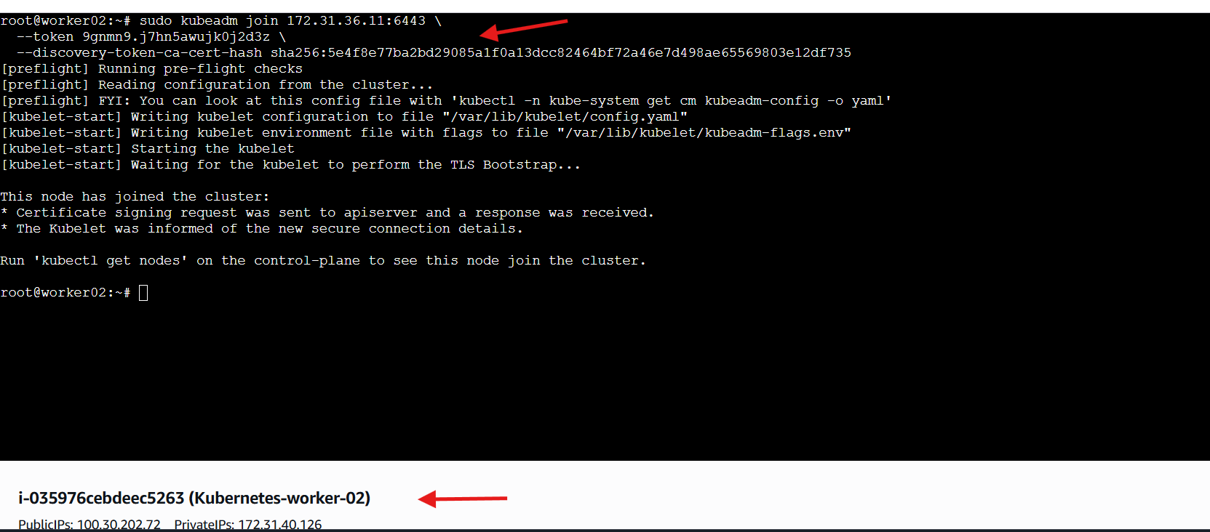

3.Run one nginx pod.
Steps Performed – Running NGINX Pod in Kubernetes
Step 1: Created NGINX Pod
Executed the following command on the master node:
kubectl run nginx --image=nginx
Outcome:
• Kubernetes created a pod named nginx
• Pod creation confirmed by system response

Step 2: Verified Pod Status
Executed:
kubectl get pods
Observed:
• Pod name → nginx
• Ready status → 1/1
• Current state → Running
• Restart count → 0
This confirmed that:
• Pod was successfully scheduled
• Container was created
• NGINX container started correctly
Final Outcome
• NGINX pod deployed successfully
• Pod state verified as Running
• Kubernetes cluster functioning correctly
